# Module 9 CCNA -IP connectivity and IP services

## Beginner Question

### Explain Perimeter, Firewall, and Internal Routers

* + 1. **Border Routers serve as a final router from outside untrusted networks and direct traffic into, out of, and throughout networks**.

### Explain types of Access Lists

* + 1. There are **four different types of ACLs**, each of which has a different use. they are reflexive, extended, dynamic, and standard.

### Explain Basic Concept of DHCP

* + 1. Dynamic Host Configuration Protocol (DHCP) is a client/server protocol that automatically provides an Internet Protocol (IP) host with its IP address and other related configuration information such as the subnet mask and default gateway.

### Explain DHCP DORA Process

* + 1. Broadcast-based DORA (Discover, Offer, Request, Acknowledgement). This process consists of the following steps: The DHCP client sends a DHCP Discover broadcast request to all available DHCP servers within range. A DHCP Offer broadcast response is received from the DHCP server, offering an

available IP address lease.

### Explain the basic operation of NAT

* + 1. Systems on the inside network are typically assigned IP addresses that cannot be routed to external networks (e.g., networks in the 10.0. 0.0/8 block).

### Explain disadvantages of using NAT

* + 1. **Translation introduces switching path delays. Conserves legally registered addresses. Causes loss of end-to-end IP traceability**.

## Intermediate Question

### How to solved Mitigating Security Issues with ACLs

* + - * 1. By controlling inbound and outbound access to network resources, ACLs ensure that the network device itself can't be accessed inappropriately or used as a conduit to attack network services beyond that router. Properly managed ACLs can serve an important role in helping to mitigate **security risks**.

### Explain Switch Port Security

* + - * 1. It **provides the ability to limit what addresses will be allowed to send traffic on individual switchports within the switched network**.

### Explain ACL with command

* + - * 1. **An access control list (ACL) consists of one or more access control entries (ACEs) that**

**collectively define the network traffic profile**.

### Explain DHCP Snooping and ARP Inspection

* + - * 1. **DHCP snooping listens to DHCP message exchanges and builds a bindings database of valid tuples (MAC address, IP address, VLAN interface)**.

### Explain DHCP Relay Agent

* + - * 1. Network administrators can use the DHCP Relay service of the SD-WAN appliances to relay requests and replies between local DHCP Clients and a remote DHCP Server.

### Types of Network Address Translation

* + - * 1. Static, Dynamic, Overload.

### Configuring Dynamic NAT

A. DONE

## Advance question

### Write basic command of Standard Access Lists

* 1. Access-list (ACL) is **a set of rules defined for controlling network traffic and reducing network attacks**. ACLs are used to filter traffic based on the set of rules defined for the incoming or outgoing of the network. These are the Access-list which are made using the source IP address only.

### Explain Telnet/SSH

* 1. Telnet and SSH use different default ports. While **Telnet can only transfer data as plain text, SSH can encrypt traffic in both directions**. Uses TCP port 23 and works best with local area networks. Uses TCP port 22 by default.

### Explain How to Configure DHCP

A. DONE

### NAT Explain with Command

1. Explain with Command

### A. DONE BOTH

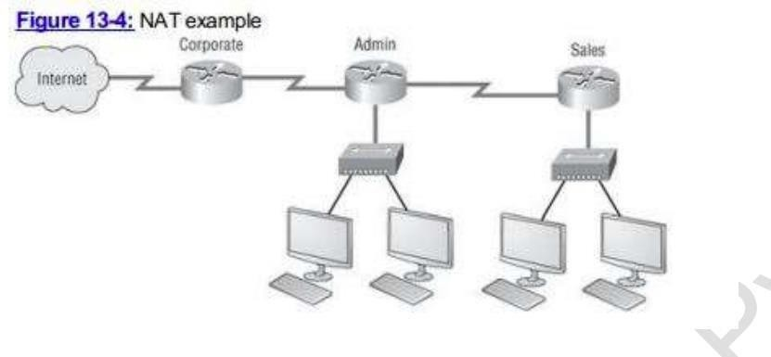

1. Explain with Command

A. DONE

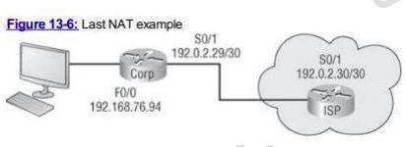

# Module 10 CCNA - Security threat landscape

## Beginner Question

### Explain Security Threat

1. What is mitigation Techniques?

## Intermediate Question

### Explain DoS Attacks

1. Explain DDoS
2. Explain IP spoofing

## Advance Question

### What is social Engineering Attack?

1. Explain Man-In-The Middle Attack